CSE 4321/5321 Homework 3

Fall 2019

**HW Discussion schedule - questions only answered according to the following schedule**

**Problems 1 and 2 - on or before 10/17**

**Problem 3 and 4 - on or before 10/24**

**Problem 5 - on or before 10/28**

Question Weighting:

Question 1- 5 - 20 % credit each - total 100% credit

Use the EBP approach for each problem.

1. Develop CFG (reduced) and Cyclomatic complexity.
2. Develop basis path set.
3. Determine significance on each variable.
4. Add tests for missing Boundary Values not tested, including extreme range values - extreme range values for EACH variable that has a boundary condition in the code.
5. For basis path use the all true path as the first test case.

Submittal items, **for each problem** ***submit*** the following

1. Code description - a decision table (except for problem 5 where you will use a graph). Use slide 61 of M03 as a guide for the decision table format.
2. CFG (reduced) - can be hand drawn and scanned
3. Cyclomatic Complexity (indicate on the graph)
4. Test case table with basis paths (put these in the "Basis Path" column - where tests are addition to basis path set use a "-" to indicate the basis path. Make sure all true is the first BP.
5. Code coverage achieved
6. Test cases support or refute description?

Assume:

1. a significance of 1 Cent on financial calculations
2. Assume 0.1 on all doubles, unless otherwise specified.
3. Use Excel's default of rounding to the significance. For financial display $0.00 and doubles 0.0 except as otherwise indicated - this will implicitly round to the significance.

Proper application of the CFG to the basis path

1. **Start at the upper left and work toward the lower right of the CFG flipping decisions from upper left toward lower right. Make sure to put nodes at subsequent levels on the CFG. See slides 41-44 of M09**

1) Use basis path testing to develop the test cases for the following code. Use the line (statement) numbers below in your CFG. Assume that batteryPower ranges from 0.0 to 1,000.0 watts both inclusive.



Test case table format:



**SOLUTION**

1. The decision table follows **(COLORS in Expected Outputs are NOT required)**:



2. and 3. The CFG follows:

ECPs/BVs **(THIS IS NOT REQUIRED)**

4. Test case table follows **(COLORS in Expected Outputs are NOT required)**:

|  |  |  |  |  |  |  |  |
| --- | --- | --- | --- | --- | --- | --- | --- |
| **Test Case Number** | **Inputs** | **Expected Outputs** | | | | | **Basis Path** |
| **batteryPower (watts)** | **red** | **yellow** | **green** | **bell** | **siren** |
| 1 | 0.0 | FALSE | FALSE | FALSE | FALSE | **TRUE** | 15-16-32 |
| 2 | 49.9 | FALSE | FALSE | FALSE | **TRUE** | FALSE | 15-18-19-32 |
| 3 | 75.0 | **TRUE** | FALSE | FALSE | FALSE | FALSE | 15-18-21-22-32 |
| 4 | 124.9 | **TRUE** | **TRUE** | FALSE | FALSE | FALSE | 15-18-21-24-25-32 |
| 5 | 250.0 | FALSE | **TRUE** | FALSE | FALSE | FALSE | 15-18-21-24-27-28-32 |
| 6 | 250.1 | FALSE | FALSE | **TRUE** | FALSE | FALSE | 15-18-21-24-**27-30-32** |
| 7 | 0.1 | FALSE | FALSE | FALSE | **TRUE** | FALSE | - |
| 8 | 50.0 | **TRUE** | FALSE | FALSE | FALSE | FALSE | - |
| 9 | 75.1 | **TRUE** | **TRUE** | FALSE | FALSE | FALSE | - |
| 10 | 125.0 | FALSE | **TRUE** | FALSE | FALSE | FALSE | - |
| 11 | 1,000.0 | FALSE | FALSE | **TRUE** | FALSE | FALSE | - |

Test cases 7-11 may appear in any order

5. Code coverage achieved is: Decision, Statement, Full Boundary Value and Extreme Range coverage.

6. They support the description (decision table).

2) Use basis path testing to develop the test cases for the following code. Use the line (statement) numbers below in your CFG. Assume that premium ranges from $0.00 to $10,000.00, safetyRating from 1 to 999, yearsMember from 0 to 50 all inclusive, and taxRate from 0.00% to 10.00%. Use, taxRate= 8.25%



Test case table format



Mentally transform statements 26-34 into a multiple condition decision statement as described in slides 41-52 of M09 and show the MCDC test cases for this logical expression in the test case table.

For the decision table (description) implement statements 12-24 as a decision table and then separately provide the logical expression for statements 26-34

**SOLUTION**

1. The decision table and logical expression follow:



The logical expression for statements 26-34 is:

primeStatus = policyHolder || yearsMember > 5 || multiPolicies && safetyRating > 500

2. and 3. The CFG follows:

ECPs/BVs **(THIS IS NOT REQUIRED)**

There are 3 sets of ECPs/BVs because we have thresholds (logical relational operators) in the code for the following:

4. Test case table follows: **(CHANGED HERE)**



MCDC test case development follows:

The logical expression is of the form a + b + cd. This has the UC solutions of:

UC 1 = FFFT, FFTF, FFTT, TFFT,FTFT

UC 2 = FFFT, FFTF, FFTT,TFFT.FTTF

UC 3 = FFFT, FFTF, FFTT,TFTF,FTFT (this was used in the test case table)

UC 4 = FFFT, FFTF, FFTT,TFTF,FTTF

MCDC test case inputs are developed as follows:



5. Code coverage achieved is: Decision, Statement, Full Boundary Value and Extreme Range coverage.

6. They support the description (decision table and logical expression).

3) Use basis path testing to develop the test cases for the following code. Use the line (statement) numbers below in your CFG. Assume distance ranges from 0.0 to 1,000.0 feet and speed from 0.0 to 100.0 all inclusive.



Test case table format:



Mentally transform statements 22-26 into a multiple condition decision statement as described in slides 41-52 of M09 and show the MCDC test cases for this logical expression in the test case table.

For the decision table (description) implement statements 9-20 as a decision table and then separately provide the logical expression for statements 22-26

SOLUTION

1. The decision table and logical expression follow:



the logical expression for statements 22-26 is:

cruiseEngaged = cruiseRequested && distance >= 50.0 && speed > 40.0 && speed <= 65.0

2. and 3. The CFG follows:



ECPs/BVs **(THIS IS NOT REQUIRED)**

There are 2 sets of ECPs/BVs because we have thresholds (logical relational operators) in the code for the following **(these are not required for the solution)**:

4. Test case table follows:

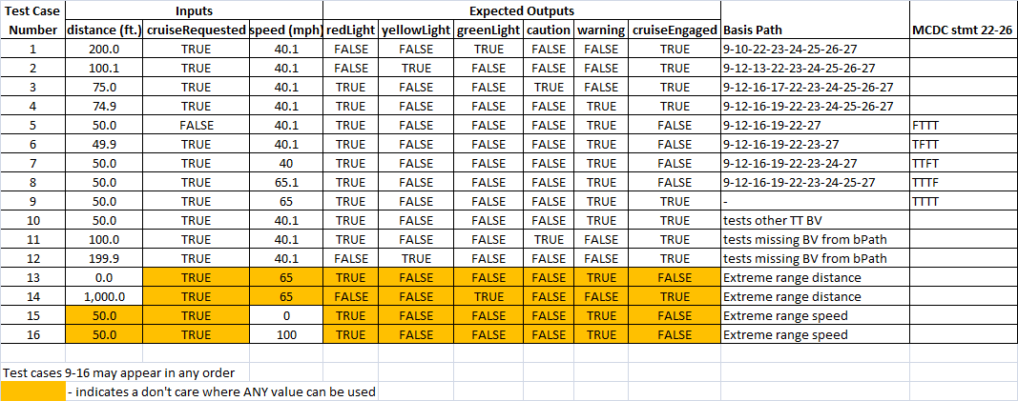 MCDC test case development follows:

the logical equivalence of statements 22-26 is: abcd (a&&b&&c&&d)

The MCDC test cases for this are: TTTT, FTTT, TFTT, TTFT, TTTF



Because of the two conditions using speed in this expression we need to draw a BV/ECP to ensure that all BVs are captured in a test. We see that the BV of 40.1 or 65.0 (whichever is chosen in test cases 5, 6, and 9) needs to have another test to test the other TT boundary.



5. Code coverage achieved is: Decision, Statement, Full Boundary Value and Extreme Range coverage.

6. They support the description (decision table and logical expression).

4) Use basis path testing to develop the test cases for the following code. Use the line (statement) numbers below in your CFG. Assume that altitude ranges from 0.0 to 10,000.0 feet and that speed ranges from 0.0 to 1,000.0 mph all inclusive.



Test case table format:



Mentally transform statements 11-14 into multiple condition decision statement as described in slides 41-52 of M09 and show the MCDC test cases for this logical expression in the test case table. Also, transform statements 16-19 in a similar manner and describe the MCDC tests similarly. As an example, "stmt 8-11 FFFF" would go in the test case table MCDC column if that is one of the test cases used to test the multiple condition statement using MCDC.

SOLUTION

1. The decision table follows:



2. and 3. The CFG follows:



ECP/BV follows **(THIS IS NOT REQUIRED):**

4. Test case table follows:



MCDC test case development follows:

the logical equivalence of statements 11-14 and 16-19 are: abc (a&&b&&c) and the test cases are

TTT, FTT, TFT, TTF

The ECP/BV for statements 11-14 is:



so we use the following test cases:



The ECP/BV for statements 16-19 is:



so we use the following test cases:



5. Code coverage achieved is: Decision, Statement, Full Boundary Value and Extreme Range coverage.

6. They support the description (decision table).

5) Use basis path testing to develop the test cases for the following code. Use the line (statement) numbers below in your CFG. Use the following template for the test case table. Assume that x ranges from -6.00 to 8.00 both inclusive. Assume both y and y are significant to 0.01 (use Excel's answer without truncation which means it will round to the 0.01).



Add tests as follows:

1. For each linear region, in the middle of the ECP.
2. For each parabolic - at the max/min and mid-range (mid-range of x) on one side of the max/min. (2 tests total).

**Submit the graph with your solution. Develop your tests using the graph. You may hand draw the graph and scan BUT IT MUST BE GRADEABLE. You must label the axes and show values across each axis at points of interest.**

Test Case table format



SOLUTION

1. The graph follows:



Both axes must be labeled and units with significance shown.

2. and 3. The CFG follows:



ECP/BV follows **(THIS IS NOT REQUIRED):**



4. Test case table follows:



5. Code coverage achieved is: Decision, Statement, Full Boundary Value and Extreme Range coverage.

6. They support the description (program graph).